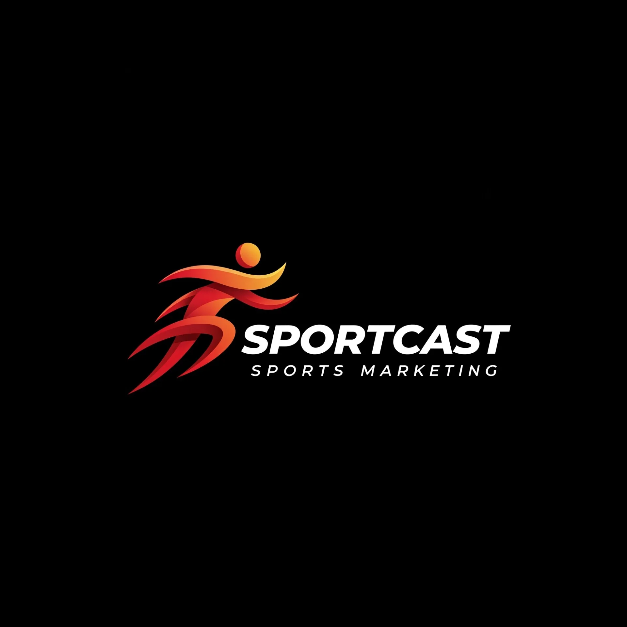

**SPORTCAST: Elevate Your Game - Dynamic Sports Marketing Solutions**

**1. Introduction: Unleashing the Power of Sports Marketing**

Welcome to Sportcast, a cutting-edge sports marketing agency that ignites passion and drives results. We're not just marketers; we're sports enthusiasts who understand the power of connection and the thrill of the game. At Sportcast, we're committed to transforming your brand and achieving unparalleled success through innovative and dynamic strategies. Explore our world at sporrtcast.com.

**2. About Sportcast: Your Strategic Partner**

* **Our Mission:**
  + To empower sports organizations and brands to achieve their marketing objectives through strategic, innovative, and impactful campaigns. We build lasting partnerships and deliver measurable results that exceed expectations.
* **Our Vision:**
  + To be a leading force in the sports marketing industry, recognized for our dynamic approach, forward-thinking strategies, and unwavering commitment to client success.
* **Our Values:**
  + **Integrity:** We operate with honesty, transparency, and ethical standards.
  + **Passion:** We are driven by a genuine love for sports and marketing.
  + **Innovation:** We embrace creativity and cutting-edge technologies to deliver unique solutions.
  + **Results-Driven:** We are committed to achieving tangible results and maximizing ROI.
* **Our Expertise:**
  + **Digital Marketing:** Social Media Management, Content Creation, SEO, Paid Advertising.
  + **Sponsorship Acquisition and Management:** Strategic partnerships, negotiation, and activation.
  + **Matchday Experience Enhancement:** Fan engagement, event planning, and atmosphere creation.
  + **Community Engagement and Outreach:** Building strong local connections and initiatives.
  + **Brand Strategy and Development:** Crafting compelling brand identities and messaging.
  + **Data Analytics and ROI Measurement:** Utilizing data to optimize campaigns and demonstrate value.

**3. The Sportcast Difference: Why Choose Us?**

* **Dynamic and Innovative Approach:**
  + We don't just follow trends; we set them. Our creative and engaging campaigns resonate with target audiences, driving brand awareness and fan loyalty.
  + We leverage cutting-edge technologies and strategies to deliver unique and impactful solutions.
* **Results-Driven Strategies:**
  + We are committed to delivering measurable results and maximizing ROI.
  + Our data-driven approach ensures that every campaign is optimized for success.
  + We track and analyze campaign performance to provide detailed reports and insights.
* **Deep Industry Knowledge:**
  + We possess a comprehensive understanding of the sports marketing landscape and its unique challenges.
  + Our expertise spans various sports and leagues, allowing us to tailor strategies to specific needs.
* **Tailored Solutions:**
  + We recognize that every client is unique. We develop customized strategies that align with your specific goals and objectives.
  + We believe in a personalized approach, ensuring that your brand stands out.
* **Client-Centric Approach:**
  + We build strong and collaborative partnerships with our clients.
  + We prioritize transparent communication and exceptional customer service.
  + We believe in working together to achieve shared success.
* **Visit sporrtcast.com:**
  + Explore our website to learn more about our services, our team, and our success stories.

**4. Our Services: A Comprehensive Suite of Solutions**

* **Digital Marketing:**
  + We manage your social media presence, create engaging content, optimize your website, and execute targeted advertising campaigns to reach your audience effectively.
* **Sponsorship:**
  + We develop strategic sponsorship plans, secure valuable partnerships, and manage all aspects of sponsorship activation to maximize your brand's exposure.
* **Matchday Experience:**
  + We create unforgettable matchday experiences through fan engagement initiatives, event planning, and promotions, enhancing the atmosphere and driving attendance.
* **Community Engagement:**
  + We build strong relationships with your local community through outreach programs and partnerships, fostering goodwill and brand loyalty.
* **Brand Development:**
  + We craft compelling brand identities, develop effective messaging, and execute brand activation campaigns to elevate your brand's presence.

**5. Our Process: A Collaborative Journey to Success**

* **Initial Consultation:** We begin by understanding your goals, challenges, and target audience.
* **Strategic Planning:** We develop a customized marketing plan based on your specific needs and objectives.
* **Campaign Execution:** We execute the marketing plan with precision and efficiency, ensuring seamless implementation.
* **Performance Measurement:** We track and analyze campaign results to optimize performance and demonstrate ROI.
* **Ongoing Optimization:** We continuously refine our strategies based on data and feedback, ensuring continuous improvement.

**6. Contact Us: Let's Elevate Your Game Together**

We're eager to discuss how Sportcast can help you achieve your marketing goals. Please contact us at:

* Website: sporrtcast.com
* Email: info@sporrtcast.com
* Phone: 0203 355 6452

Let's work together to drive your sports marketing success and elevate your game.